**Contents**

**Introductions**

**Designs**

Sketches

Homepage sketch

CV page sketch

Biography page sketch

Contact page sketch

Wireframes

Wireframe of my Homepage

Wireframe of my CV page

Wireframe of my Biography page

Wireframe of my Contact page

Screenshot of my webpage

Homepage screenshot

CV page screenshot

Biography page screenshot

Contact page screenshot

Testing

**Introduction:**

We were assign to create personal webpage using HTML and CSS. And we were suggested to learn from [www.w3sclools.com](http://www.w3sclools.com) to use various codes for our webpage. But I had no idea about the design. So, I went looking for getting some idea from different websites like [www.wix.com](http://www.wix.com) and <https://joel.sh/about> and It was very effective and helpful for create my own webpage. In our assignment we are asked to create four HTML webpage using CSS like Index.html, CV.html, Bio.html, and Contact.html abide by certain rules.

**Designs:**

**Sketches**

Sketch of Homepage.

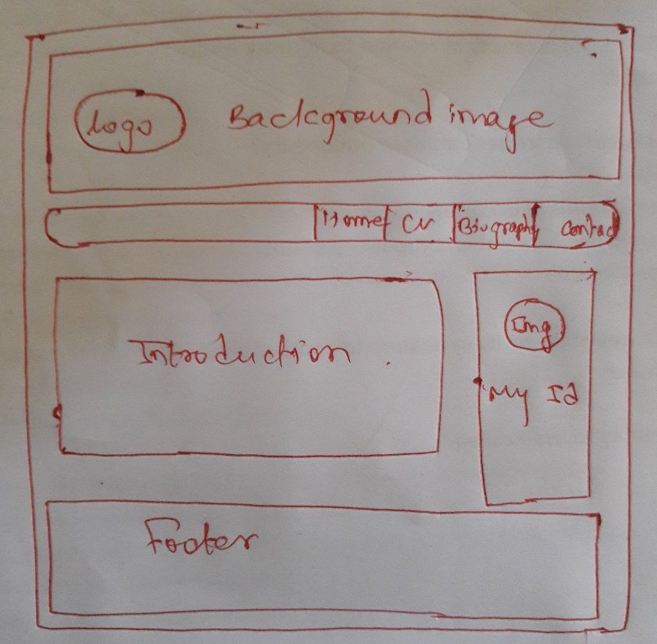I would like my homepage to be simple and easy to understand by the user . I will have my own logo on the left corner of the header and then menubar right below the header part. Menubar will contain Home, CV, Biography, and Contact page link to eachother and on hover it will increase its size. Then there will be two division in a row on the section part. 1st division will contain introduction and 2nd will contain about my ID. I will place my image on the center of the 2nd division which on hover increase its size. And at last, there will be footer on the bottom of the page which will contain my contact details.

Sketch of CV page.

Header, menubar and footer will be same in all the page. My CV page will have “curriculumn vitae” written below the menubar as a title of the and five division along with it. These division will include my skills, experience, relevant course work and education. And I will also place my image in one of this division which on hover will rotate.

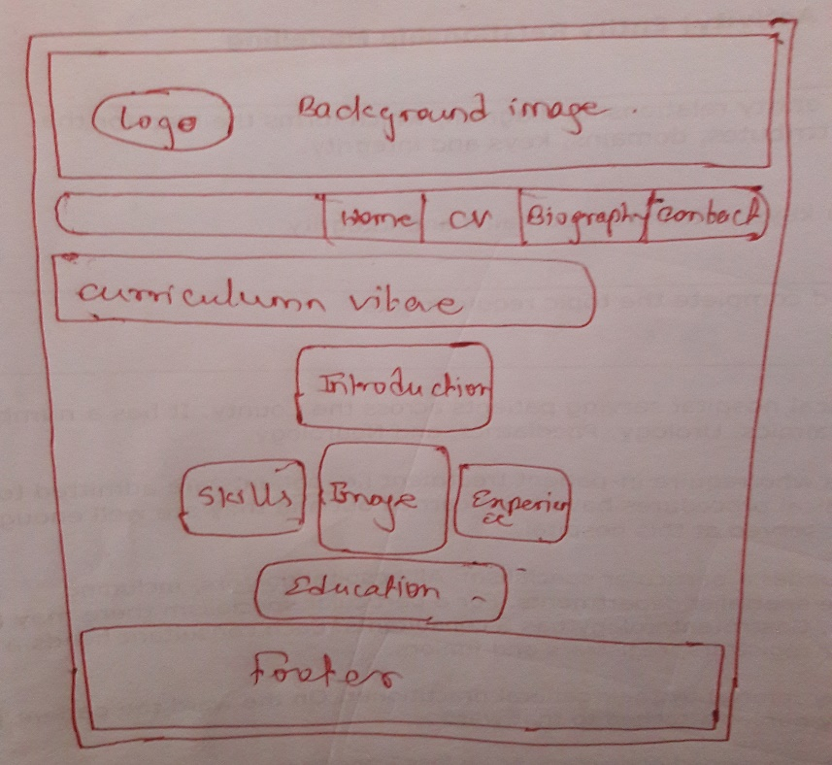

Sketch of Biography page.

For the biography page, there will be written “Biograohy” just like cv page below the menubar. And in the section part there will be three division in a row. First and last division will contain about me and second will include my image which on hover will increase its opacity.

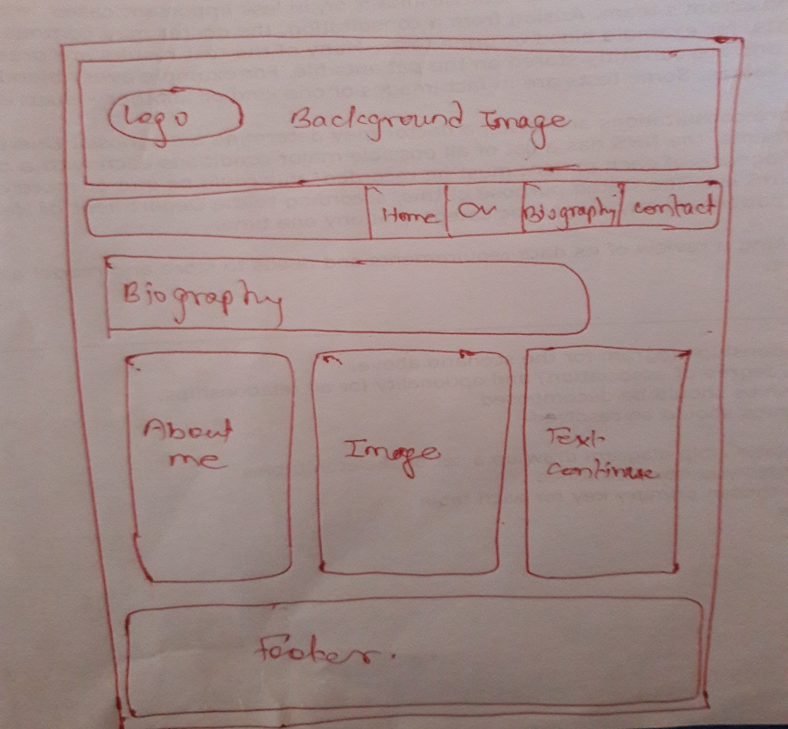

Sketch of contact page.

Contact page will also have “Contact” written below the menubar. The section part will contain two division, one will contain the contact form and other will contain my picture. The contact form will include firstname, lastname, gender, and email. While clicking on these boxes will change its color.

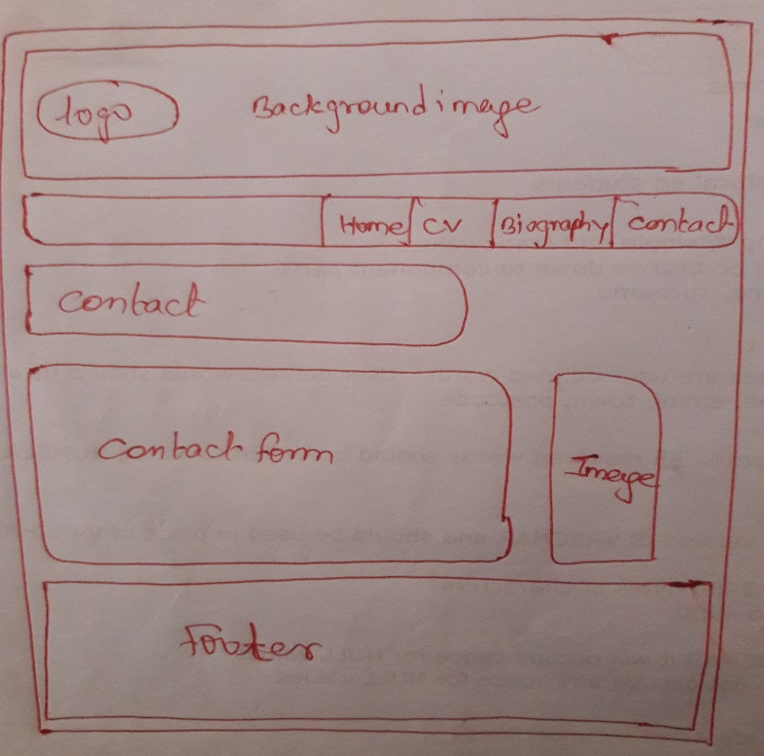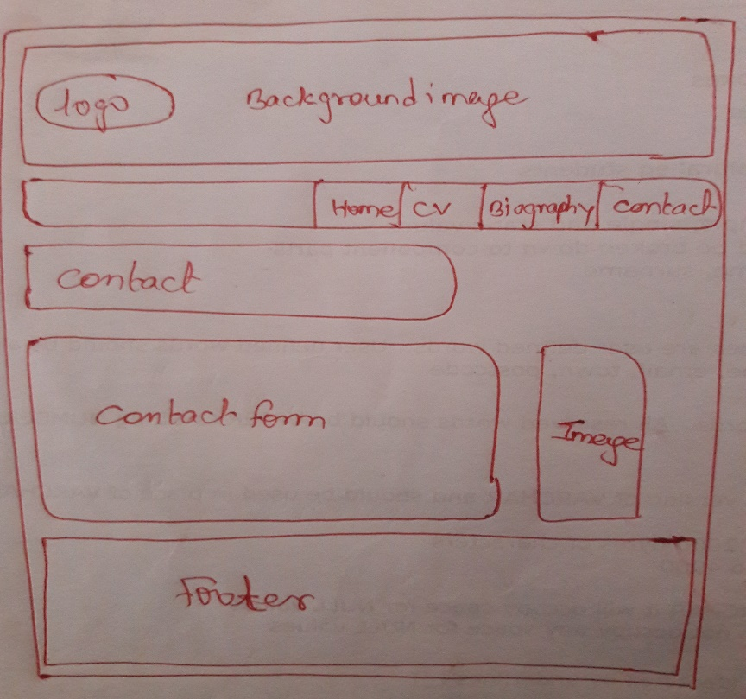

**Wireframes:**

Wireframe of my homepage.

Footer

My ID

Home

Contact

CV

Biography

Introduction

Wireframe of my CV page.

Curriculumn vitae

Biography

Contact

Home

CV

Details about me

Image

Skills

Experience

Education

Footer

Wireframe of my biography page.

Biography

Contact

Biography

CV

Home

Image

About me

Continue..

Footer

Wireframe of my contact page.

Contact

Contact

Biography

Home

CV

Contact form

Image

Footer

**Screenshot of my webpage:**

Homepage screenshot

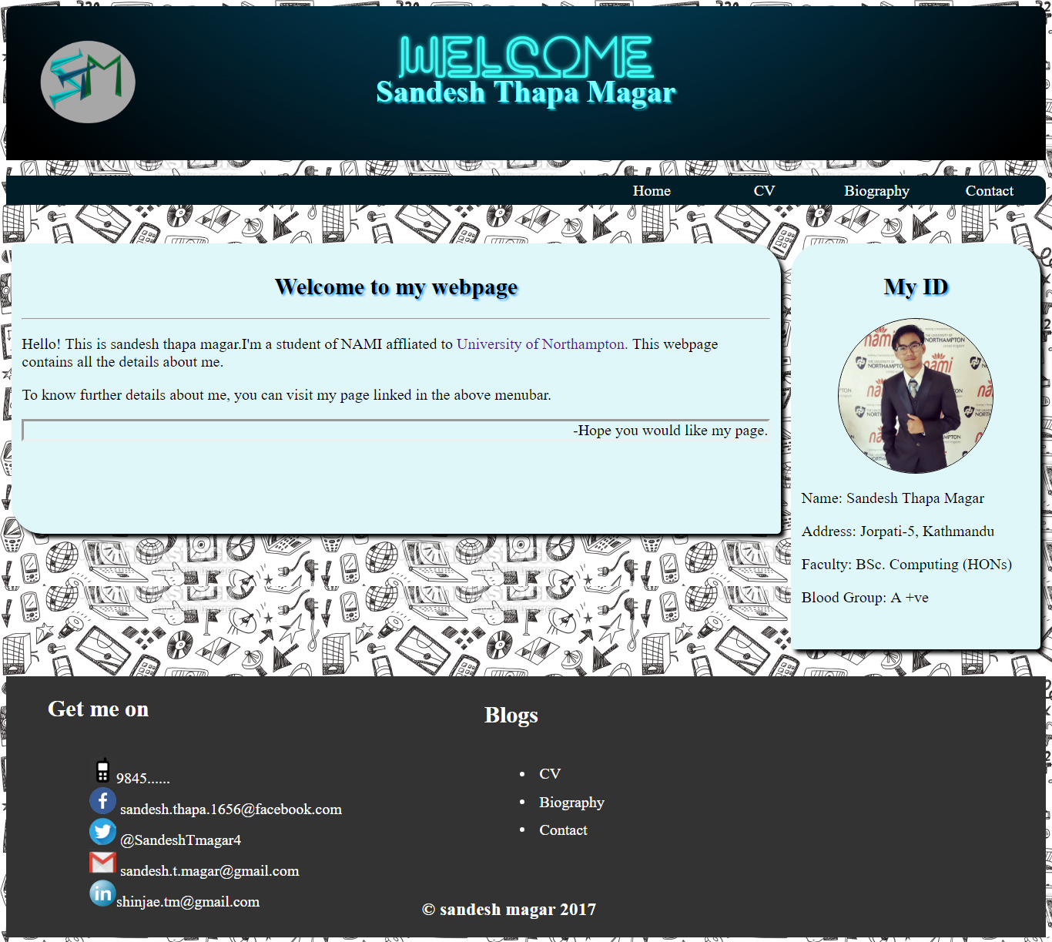

CV page screeshot

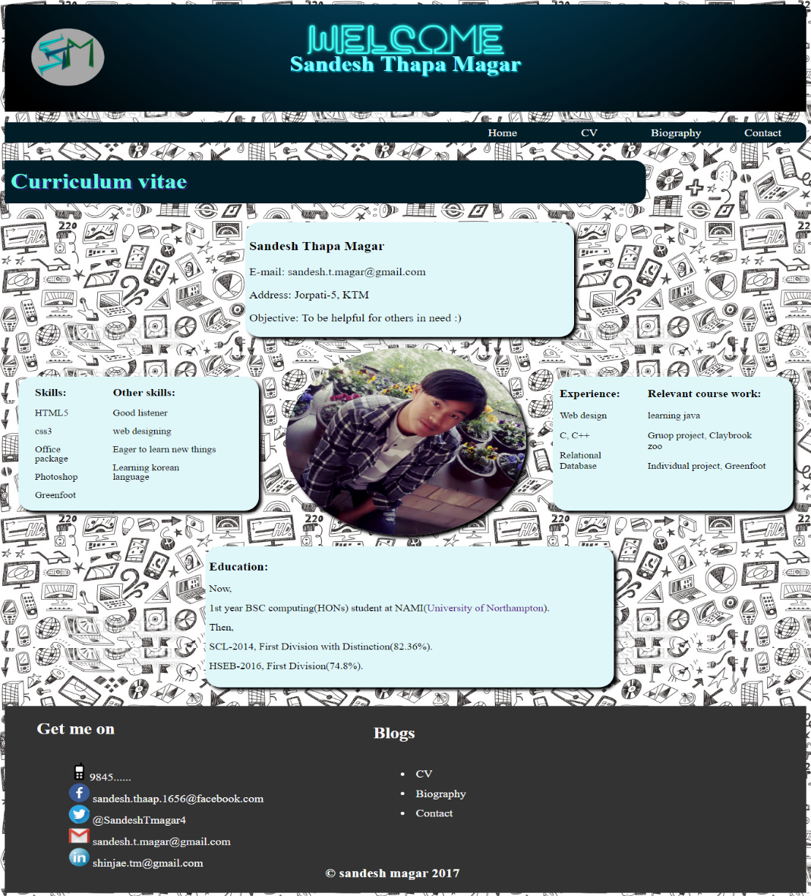

Biography page screenshot

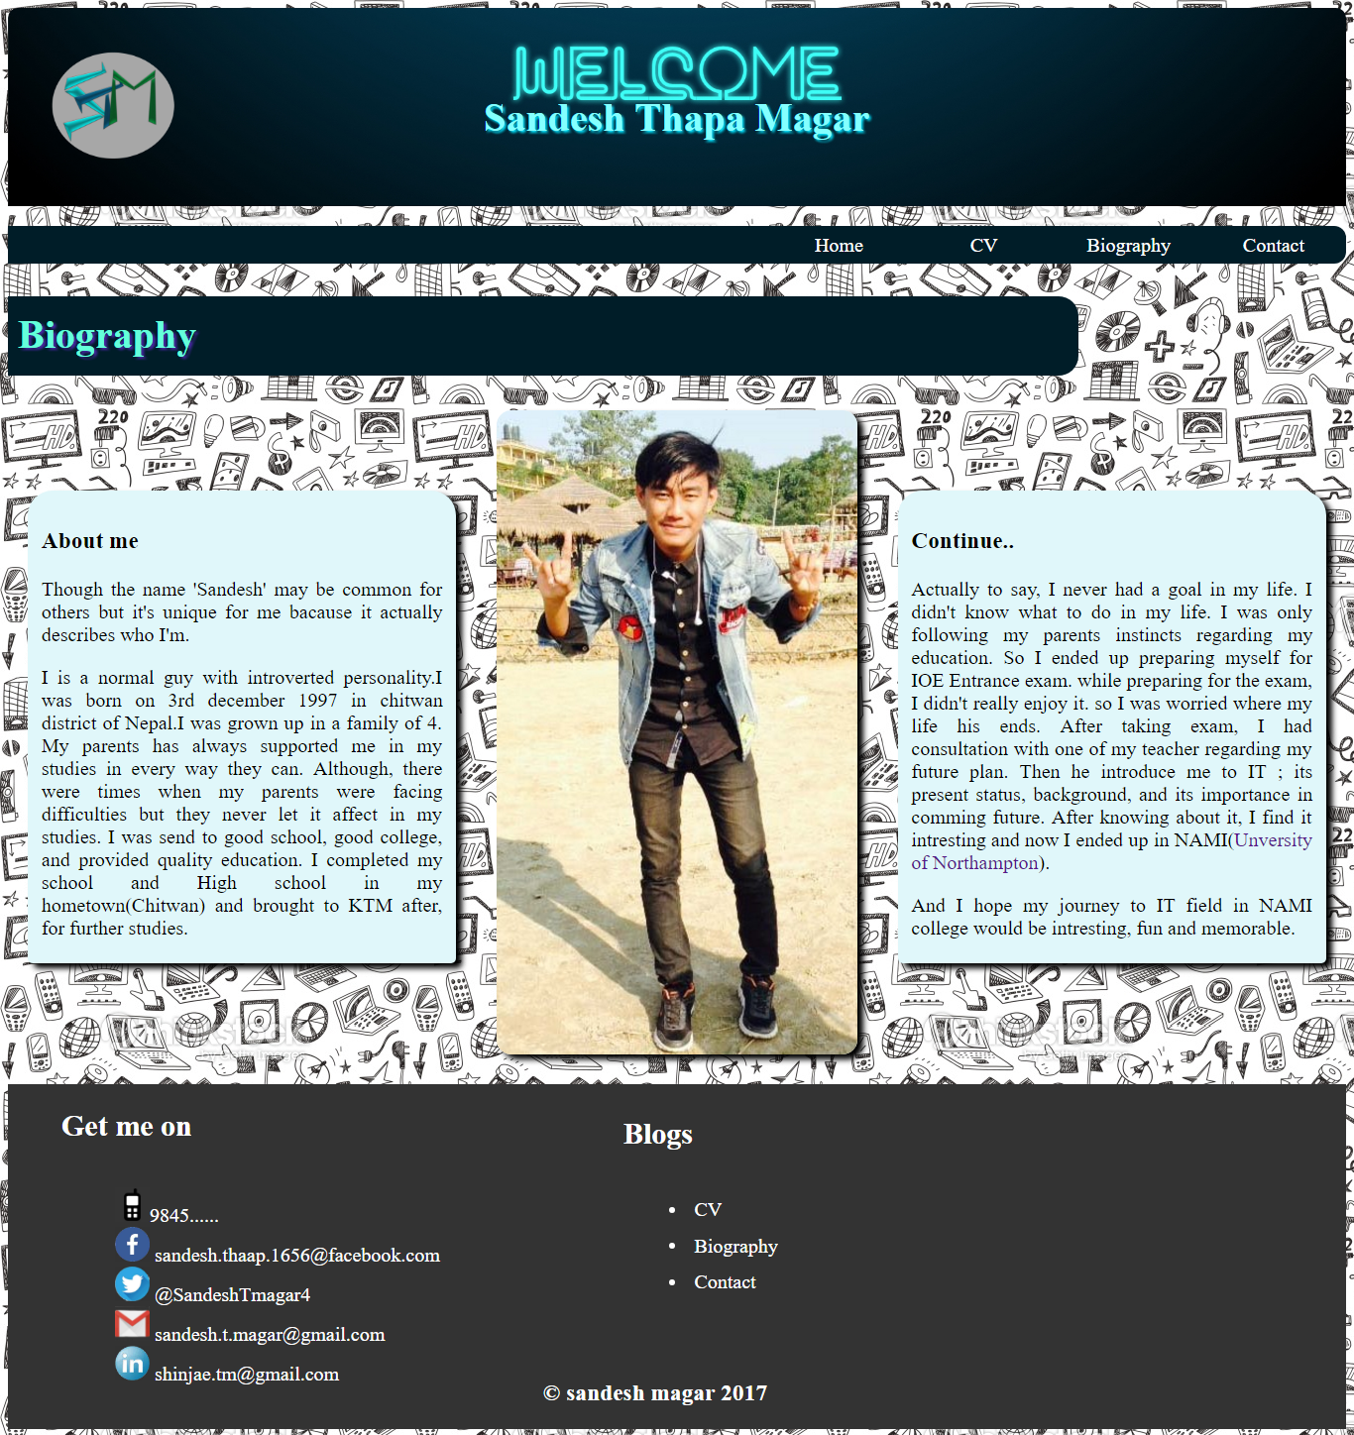

Contact page screenshot

